A+W Press Release Linden, September 30th, 2013

“Best in Show Booth – Interesting Deals for A+W
For the second year running, the American National Glass Association (NGA) has awarded A+W the coveted award for the best booth at GlassBuild America (GBA) in Atlanta, this time together with its parent company, Friedman Corporation. Business-wise, the show has been a great success as well: One could feel that the North-American market is in its second year of economic pick-up and that the companies are investing in software again.

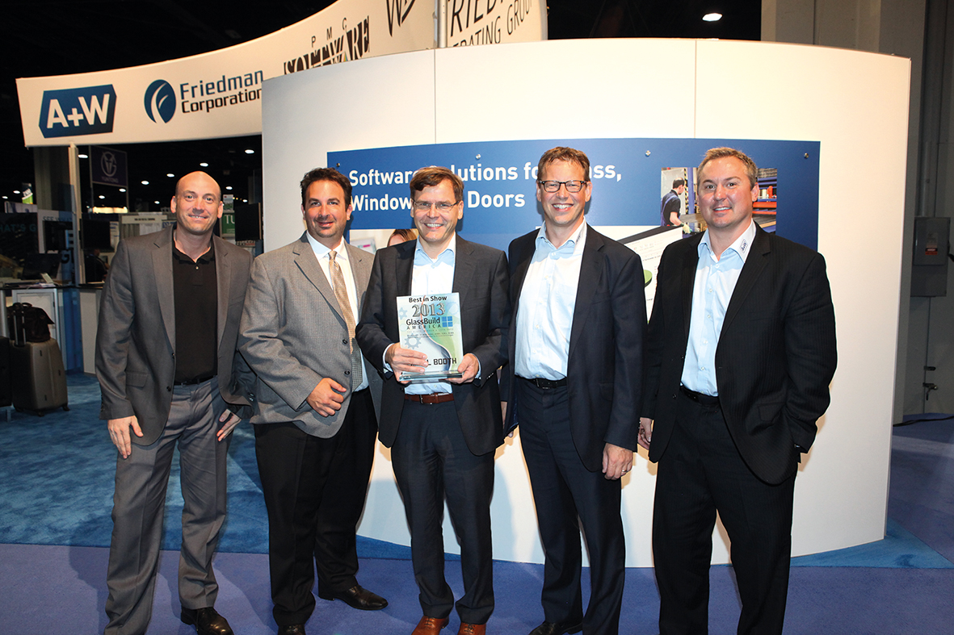
Max Perilstein, NGA, on the award-winning booth: “Your booth truly was amazing. One of the best I have seen in all my years.” The A+W team received the award on behalf of the Friedman Corporation.
As the youngest member of the Friedman Group, A+W experienced a brisk demand for the new products. There were so many visitors at the booth that the staff was completely booked with demos and requests.
All of the A+W solutions were on demand but especially the new A+W Business Pro, a solution for small and medium-sized flat glass companies (see article on p. 53) which was presented for the first time in North America. The CANTOR solution for windows and doors was very popular as well. Dr. Uwe Schmid, CEO of A+W: “Our presence at the Friedman booth in combination with the new American team strengthens the American market’s trust in the A+W brand. This has resulted in several interesting deals for us here at GBA. The leads were a lot more tangible than just a year before in Las Vegas – we could feel that the North American market is experiencing its second year of economic pick-up”..
Proud of the award for the most attractive booth at GBA 2013 – from left: Eike Luh, Director Customer Service A+W
North America; Martin Gwynn, Sales Manager PMC Software Corporation; Dr. Uwe Schmid, CEO A+W; Peter Dixen, Vice President Sales & Marketing A+W; Robert Anderson, Director of Sales A+W North America.

Peter Dixen, A+W Sales Director: „The American industry has been quick in realizing that we have strengthened our presence in the USA considerably and that Friedman’s CEO Mark Thompson is now at the head of our team. Mark is one of the pillars of strength of the American glass and window industry and enjoys a lot of confidence there. Favorably received was also the reinforcement of the window and door team in the shape of Shawn Graska, also a well-known face in the industry. We are well on our way in North America.”

A+W Software USA Inc.
usa@a-w.com | www.a-w.com

